Skin Cancer detection
using
Convolutional Neural Network

Under the Guidance of
Dr. Agilandeeswari L
For the course ITE1015 – Soft Computing
(Associate Professor, School of Information Technology and Engineering)
For the Program B. Tech. in Information Technology
Semester: Winter Semester 2020-21

Project Team:
Aashish Bansal 19BIT0346
Keerthi Yasavi 19BIT0335
Perumalla Sasank 19BIT0338

Abstract

Keywords

Introduction
- The significant growth of medical images and techniques requires comprehensive and exhaustive efforts from a medical professional who is susceptible to human error and the result can also vary widely among various experts.
- In this project, we have used the above stated idea behind disease detection, to develop a system using convolutional neural network (CNN) that will help in detection of a particular disease.
- The system has been made user-friendly with the help of GUI, so that it can be used not only by the medical professionals but also by the population at large.

General Architecture
About the Diseases:

- Skin cancer is an abnormal growth of skin cells. Most skin cancers are caused by exposure to ultraviolet (UV) light. When the skin is not protected, UV rays from sunlight or tanning beds can damage and alter skin's DNA that leads to the cancer.

- Deep learning model has been built to classify and identify the binary diagnostic group of melanocytic images obtained through dermoscopy.

- Based on the model, disease detection through dermal cell images has been investigated, and classifications on dermal cell images have been performed.

Motivation

- Disease detection plays a very important role in the process of diagnosis. Therefore, the motivation lies in accurate classification and detection of the diseases based on medical images.
- The main aim is to minimize the chances of error that might happen due to the doctor's misjudgement.
- Developing a system that will not only help in detecting the diseases efficiently but will also save the time and effort of the medical practitioners.
- This will also save the patients from running to the doctor to get their medical reports verified.

Methodology and System Design:

Image Processing

- Image processing can be defined as the technical analysis of an image by using complex algorithms.

- The purpose of early image processing was to improve the quality of the image. Its use has been increasing exponentially in the last decades.

- Its applications range from medicine to entertainment, passing by geological processing and remote sensing.

Convolutional Neural Network (CNN)

- A Convolutional Neural Network (CNN) is comprised of one or more convolutional layers (often with a subsampling step) and then followed by one or more fully connected layers as in a standard multilayer neural network.

- The architecture of a CNN is designed to take advantage of the 2D structure of an input image. This is achieved with local connections and tied weights followed by some form of pooling which results in translation invariant features.

- Another benefit of CNNs is that they are easier to train and have fewer parameters than fully connected networks with the same number of hidden units.

MODEL:

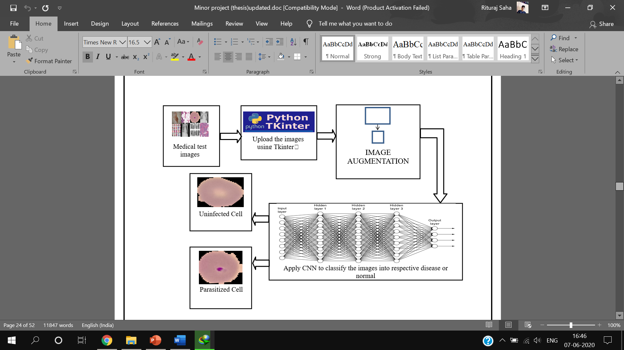

Future Scope:

- Implementation of various other algorithms and using several optimization techniques. Also more data will be collected in order to recognize the features more accurately.

- Major attention will be given to increase the accuracy such that our proposed system can be used to detect a large number of chronic and critical diseases.

- When these enhancements are done, the system can be integrated with an android application to make it more convenient and easily portable. This will allow people from all strata to use it effectively even if they do not have a personal computer.

Review on various schemes (mention appropriate references)

Image acquisition:

Image Pre-processing:

Image Segmentation:
ROI from NON-ROI
Feature Extraction
Classification

Image acquisition & pre-processing:

- The dataset comprising of RGB images of skin samples has been taken. The images were of 224x224 pixels.

- The dataset is then divided into the train set and test set of /*NUMBER*/ and /*NUMBER*/ images respectively.

- A CNN model of 4 convolutional layers and one fully connected layer has been developed.

- For activation, ‘relu’ is applied to the output layer and hidden layers respectively.

Classification:

2D network

Comparative study on various subtitles (using table):

Authors &Year | Methodology or Techniques used | Advantages | Issues | Metrics used
May-20 | CNN, AlexNet, ResNet-18, VGG16, SVM, Black-hat filter, Inpaint Algorithm, Median Filter, Otsu’s Methodology | SVM Accuracy = 86.21%, ResNet Accuracy = 87% | Accuracy Original Data = 80%, Accuracy Augmented Data = 98.61% | ReLU, CNN with Data Augmentation = 88.87%, CNN without Data Augmentation = 78.96%
2020 | CNN, Inception-v3, Keras, TensorFlow, DCNN, LeakyReLU, Adamax optimizer, TPR is similar to the positive predictive value | 0.86 AUROC for BKL | 0.78 AUROC for MEL | Accuracy
2020 | MVSM classifier, CNN, feature extraction, GLCM, SVM, ABCD | dataset which consists of eight different classes is compressed into 800 images and applied, The accuracy achieved is about 96.25%. | accuracy is lowered if minute amounts of foreign elements are found on the sample | Accuracy
2020 | CNN SENet154, WSL, Adam, weighted loss-entropy | Efficient Architecture | Not much improved with ensemble strategy | EfficientNet, SENet (T1 = 67.2%, T2 = 70.0%), ResNeXt WSL (T1 = 65.9%, T2 = 68.1%)
2020 | GLCM, HOG, GAC | Feature extraction for early detection | Not enough/adequate dataset | ABCD Rule, SVM Classifier, Accuracy, Sensitivity, Specificity using KNN
2019 | Multiclass SVM, AlexNet, ReLU | Accuracy – 94.016% | Model used is a pre-trained model, robust | GOPS, L1D miss rate
2019 | CNN, pooling layers, dense network, SVM | AlexNet, VGG16, ResNet-18 | Deep Network but Small Dataset – 3000 images | Accuracy = 74%
Apr-19 | CNN, pooling layer, dense network | Accuracy – 89.5% | Time consuming | Accuracy = 89.5%, Recall = 0.84, Specificity, Precision = 0.8325, F-measure = 0.8325
Mar-19 | CNN, Inception V2 Net, K-means Cluster, Max-pooling, Sonification Algorithms | No. of K-means Epochs = 100 | F2-score +ve Prediction = 59.9%, High Sensitivity, Low Specificity | F2-score = 81.8%, Sensitivity = 91.7%, Specificity = 41.8%, Precision = 57.3%
2019 | CNN, McNemar Test, ResNet50, Bonferroni Correction | MATLAB | Small dataset (11,444), training may be inefficient, class imbalance | Accuracy = 100%, detection rate = 100%
2018-2019 | CNN, VGG16, ImageNet | Accuracy – 92.5%, Max-pooling fetches maximum pixel | F1-score = 0.77, VGG16 Accuracy = 78% | Random Forest = 65.9%, XGBoost = 65.15%, SVM = 65.86%, ReLU, Sigmoid
2018 | MatConvNet & GoogLeNet Inception V3 CNN, GoogLeNet, AlexNet, ResNet, VGGNet, Simple Majority Voting, SMP | 1.28 million NATURAL images 500 epochs, pre-trained models used, MatConvNet provides pre-trained CNN models and some functions to create and initialize new neural networks | Limited computational resources, time-consuming procedures | GoggLeNet Error Rate = 0.1, ResNet Error Rate= 0.02, AlexNet Error Rate = approx. 0.001, VGGNet Error Rate = approx. 0.001
Mohammad Ashraf Ottom 2019 | CNN | 2000 images provided by ISIC (International  Skin Imaging Collaboration) | accuracy 74% | CNN; melanoma;  skin cancer; image preprocessing
Abhinav Sagar 2020 | CNN,ANN, Fuzzy Measures,SVM | CNN,ANN, Fuzzy Measures,SVM |  | Accuracy and pression
Muhammad Rukunuddin Ghalib 2017 | SVM, KNN, Decision Tree, Boosted Tree | Trained on different models | Improper accuracy | KNN is 92.70%, SVM is 93.70%, Decision tree (DT) is 89.5% ,boosted tree (BT) is 84.30%.
Hema Rajini Narayanan 2017 | KNN, SVM and CNN | Trained on different models | Very small daaset | KNN 85%,SVM 96% CNN 98%
Dr. SHAILAJA K 2017 | SVM | spot analysis and guides for the direction of spread of the cancer | Improper pixel results errors | Edge and line detection
Mohammad AliKadampur 2020 | CNN | classify dermal cell images and detect skin cancer. | accuracy of less than 76% | Accuracy  Image classification
Titus Josef Brinker 2018 | skin lesions using CNNs | large dataset and large variety | dermoscopic patterns are not considered here | Good dataset
Andre Esteva and Brett Kuprel 2017 | CNN | 129,450 clinical images of dataset and  2,032 different diseases | No pre-processing | Large variety
Noel B. Linsangan 2018 | KNN | 86.67% accuracy in determining the classification. | Small dataset | Accuracy but small dataset
Daniel J Kadouch 2016 | K-Means | Faster identificaion | Melanoma can be fatal if not diagnosed at early stage. | accuracy of identification of skin cancer from dermoscopic images is directly proportional to the accuracy of the skin lesion segmentation
2017 | GANs, CNN, AlexNet, StyleGANs, InceptionV3-StyleGANs, ResNet50- StyleGANs, VGG16BN- StyleGANs | size of 600×600 as input dataset, | sets the weight coefficient w in the softmax loss function | Accuracy
2018 | CNN, SciKit, Keras, TensorFlow, OpenCV, ReLU | 90% accuracry, Convolution maintains the spatial interrelation of the pixels, values of the pixels ranging from 0 - 255 i.e 256 pixels. | Rectified Linear Unit is a non-linear operation. ReLU acts on an elementary level. | Accuracy
2019 | AlexNet, Ordinary CNN, VGG-16, LIN, Inception-v3, and ResNet. Lévy flight, ReLU | size of input images in the input is considered 28×28 pixel. | doesn’t give the best global solution | Accuracy
2019 | STM32, ROC, CNN, ReLu, NLSC | Accuracy - 99%,  F1-Score - 99% | computing and index loss, poor lesion skin discrimination specificity | Accuracy
2019 | CNN, Feature Extraction, HSV format | Accuracy of 98%. for melanoma skin cancer detection and 93% for melanoma type, TPR of 94.25%, FPR of 3.56%, and EP of 4%, average accuracy of 91.66% | high error rates, 25.6% Caucasian error and 23.2 Xanthous error, validation loss of 57.56% | Accuracy
2019 | CNN, keras, AlexNet, VGG16, SGD optimiser, | trained on more than 126k images, higher image augmentation (24x) and image resolution (1k), the same performances can be achieved using less than 5000 images, No impact of image resize filters | Experiments at 277x277 pixel resolution, Experiments without transfer learning | Accuracy
2019 | CNN, grad-CAM, TensorFlow, Inception-ResNet-v2, DenseNet121, Xception | consists of 150,223 clinical images from 543 different skin diseases, achieved an accuracy of 87.25 ± 2.24% on the dermoscopic images for four common skin diseases, including SK, BCC, psoriasis and melanocytic nevus. | highest average precision (77.0%) | Accuracy
2019 | CNN, keras, Tensorflow, Inception V3, ResNet50, VGG16, MobileNet and InceptionResnet | 7 types of skin lesion diseases identification namely: Benign Keratosis, Dermatofibroma, Vascular Lesion, Melanoma, Melanocytic Nevus, Basal Cell Carcinoma and Actinic Keratosis., InceptionResnet achieved an average accuracy of 91%, Accuracies of 90 and 91% | low F1 score | Accuracy

References:

- ResearchGate.com

- ScienceDirect.com

- GeeksforGeeks.com

- TutorialsPoint.com

- cs.stanford.edu

- Springer.com

- towardsdatascience.com

- academictorrents.com

- kaagle.com

Conclusions:

- A “health discernment system” has been proposed for medical image classification that will work in real-life scenarios.

- The proposed method is based on /*NAME*/ architecture.

- Different sub-models pertaining to the two diseases (skin cancer: Melanoma, Benign) have been designed using convolutional neural network (CNN) and they have all been tested separately.

- A GUI based web application has been designed using Tkinter so that the system can take real-life image inputs for detection.

Authors | Methodology or Techniques used | Advantages | Issues | Metrics used
 |  |  |  | Accuracy, Precision, F-Score , Recall, ROC

Conclusions (Among various schemes which is best for which application)

References ([1] [2],….)
[1]

[Note: Text given in red is for example]

--------------------------------------------------------------------------------------------------

